Understanding Attention in Transformer Models
Yousif Abdulhussein, Margaret Kelley, Alex Warden, Jingtao Zhong
COSC 524: Natural Language Processing, Fall 2025

In recent years, the transformer architecture has emerged as the foundation for many state-of-the-art systems in natural language processing (NLP). Tasks such as language translation, text summarization, and question answering are now powered by these models. Much of this success can be attributed to the self-attention mechanism. Self-attention models the relationships between tokens, which can be thought of as words, within a sequence by allowing neural networks to update their embeddings, or ‘understanding,’ of each token in relation to its surrounding context.
Although self-attention was initially applied within recurrent neural networks (RNNs), their sequential nature created a major computational bottleneck. Transformers overcame this limitation by computing attention scores across all tokens simultaneously, rather than processing them step by step. This parallelization allows transformers to efficiently learn and represent long-range dependencies. As a result, these models can leverage large-scale computational resources to process long sequences of text and train on massive datasets without being constrained by sequential processing.. This parallelizable architecture of transformers has enabled the possibility for large-scale deployment of models that can be trained on extensive corpora with high efficiency.
Transformers also introduce a key technique, known as multi-headed self-attention (MHA). Instead of relying on a single attention mechanism, the model employs multiple heads, each capable of focusing on different linguistic or semantic features. For example, one head might learn syntactic structures, while another captures semantic relationships or discourse-level cues. Combining the insights from multiple heads produces a richer and more nuanced representation of language. MHA increases a model’s robustness and enables more effective utilization of large-scale compute and data resources.
Despite their transformative impact, transformer architectures remain only partially understood. While some attention heads exhibit interpretable behaviors–such as attending to punctuation or specific syntactic relationships–many remain opaque This is a direct consequence of the data-driven learning process used to train modern large language models (LLMs). As artificial intelligence (AI) systems become more deeply integrated into critical applications and tooling, it becomes increasingly more important to develop a comprehensive understanding of how these models function in order to ensure their safety and reliability.
At times, attention heads display systematic patterns; at others, their roles appear arbitrary or difficult to interpret. Therefore, it is essential to develop methods to better understand attention. Not only for interpretability, but also for improving model design and fostering trust in their outputs.

Existing Tools for Visualizing Attention
Our research builds upon two main areas: interactive visualization systems for exploring attention, and analytical studies investigating the linguistic knowledge that is encoded by transformer models.
- BertViz (Jesse Vig, 2019): Among existing visualization tools, this is the most widely recognized tool for attention visualization. It provides an interactive interface to examine attention patterns between tokens across all layers and heads. Its neuron and model views are valuable for qualitative exploration of short text sequences–often revealing high-level structural patterns. However, BertViz primarily serves as an exploratory tool; it does not generate quantitative data to characterize attention head behavior patterns. Additionally, its performance diminishes when applied to longer or more complex datasets.
- VizBERT (Vig et al., 2020): This tool emphasizes the visualization of token embedding transformations across layers by employing dimensionally reduction methods such as t-SNE and PCA, rather than manipulating the attention weights directly. Although this approach offers valuable insight into representation learning, it does not directly explain how attention functions.
- exBERT (Hoover et al., 2020): A lightweight framework for exploring token representations and their similarity relationships. Like VizBERT, it focuses more on activation analysis than attention mechanisms, but it demonstrates how interactive interfaces enhance model interpretability.

Seminal Interpretability Studies
Two key studies form the theoretical basis of our approach, illustrating both the promise and the limitations of attention-based interpretation.
- "What Does BERT Look At? An Analysis of BERT’s Attention" (Clark et al., 2019): This study performed an extensive analysis of attention heads within a fine-tuned BERT model. Through manual inspection and probing, the researchers identified attention heads that consistently focused on specific linguistic phenomena–such as attending to delimiters ([SEP]), neighboring tokens, or syntactic dependencies (e.g., linking verbs to objects or adjectives to nouns).. Their findings demonstrated that individual heads could specialize in distinct linguistic functions, offering evidence that attention encodes interpretable structures.
- "Attention is Not Explanation" (Jain & Wallace, 2019): This paper presents a critical counterpoint. The authors argue attention weights are often weakly correlated with other measures of feature importance, showing that different attention configurations can yield identical model outputs. Consequently, they caution against interpreting high attention scores as direct explanations for model predictions. In light of this critique, our work focuses on identifying what kind of information particular heads tend to process–rather than claiming attention provides a complete explanation. By analyzing how attention relates to syntactic and semantic structures, we aim to better understand how individual heads function within the broader model architecture.

Methodology

Dataset

Our analysis employs the Stanford Natural Language Inference (SNLI) dataset. SNLI contains sentence pairs labeled as entailment, contradiction, or neutral. Because SNLI inherently involves reasoning between two sentences–a “premise” and a “hypothesis”–it provides an ideal framework for how attention flows between the models and allows us to observe not only how attention operates within each sentence but also how it flows between them.

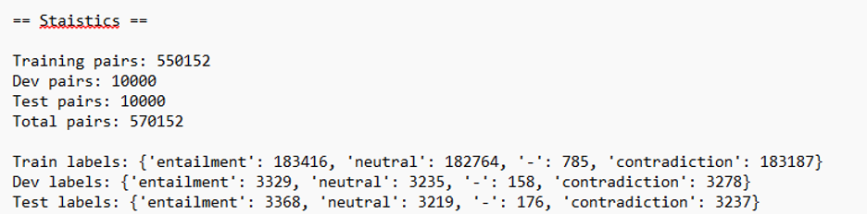

Experimental Setup

To establish an initial performance benchmark, the first 1,000 samples from the SNLI test set were evaluated. The label encoding schema for the SNLI dataset had entailment, neutral, and contradiction assigned to 0, 1, and 2 respectively This evaluation produced an overall accuracy of 89.70%, as summarized in the confusion matrix shown in Figure 1.

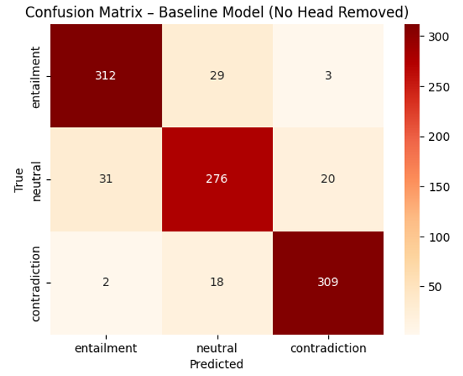

Our analysis is conducted using the BERT-base-uncased model. This version of BERT has 12 layers, each with 12 attention heads, resulting in a total of 144 heads to study. We do not modify or fine-tune the model because keeping the model in its pre-trained form, we can better understand its general internal behavior rather than task-specific adaptations.

During our analysis, cross-attention scores were extracted for all 144 attention heads. However, only the 897 samples that were predicted correctly were included in the analysis in order to ensure that the attention patterns that result reflect meaningful reasoning behavior and limit the noise that comes up as a result of misclassified cases.

To better differentiate the different attention heads, the variance of attention heads was calculated by equation 1.

$Var(L_{i},H_{j})=\frac{1}{C}{\sum_{k=1}^{C}{}{(u}_{i,j}}^{k}-{\underline{u}}_{i,j})^{2}$

Here, C is the number of classes (C is 3 here), ${u_{i,j}}^{k}$ means the mean attention score of head i^{th} layers with j^{th} head (L_{i}, H_{j}) for class K, and ${\underline{u}}_{i,j}$ is the overall mean attention score for three classes.

A larger variance for a head indicates that the head responds differently across categories, thus being more discriminative. A smaller variance implies that this head yields similar attention patterns for all categories, suggesting it may be redundant or less informative for the task at hand.

Parameter reduction Experiment

Two methods were developed to identify the least and most significant parameters so that we could properly reduce parameters. Figure 2, Figure 3, and Figure 4 provide the distribution of mean cross attention score for each attention head for three classification tasks. The first three layers did not present significant differences among different tasks. This suggests that many of their heads capture general features rather than task-specific distinctions, so it is possible to remove some attention heads from those layers.

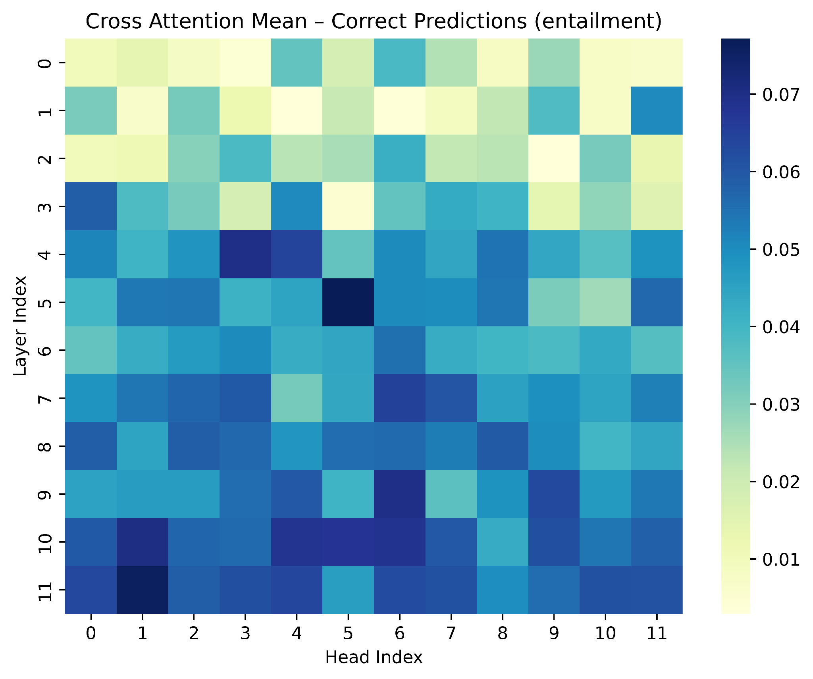

Figure 2. Mean cross attention scores for entailment prediction

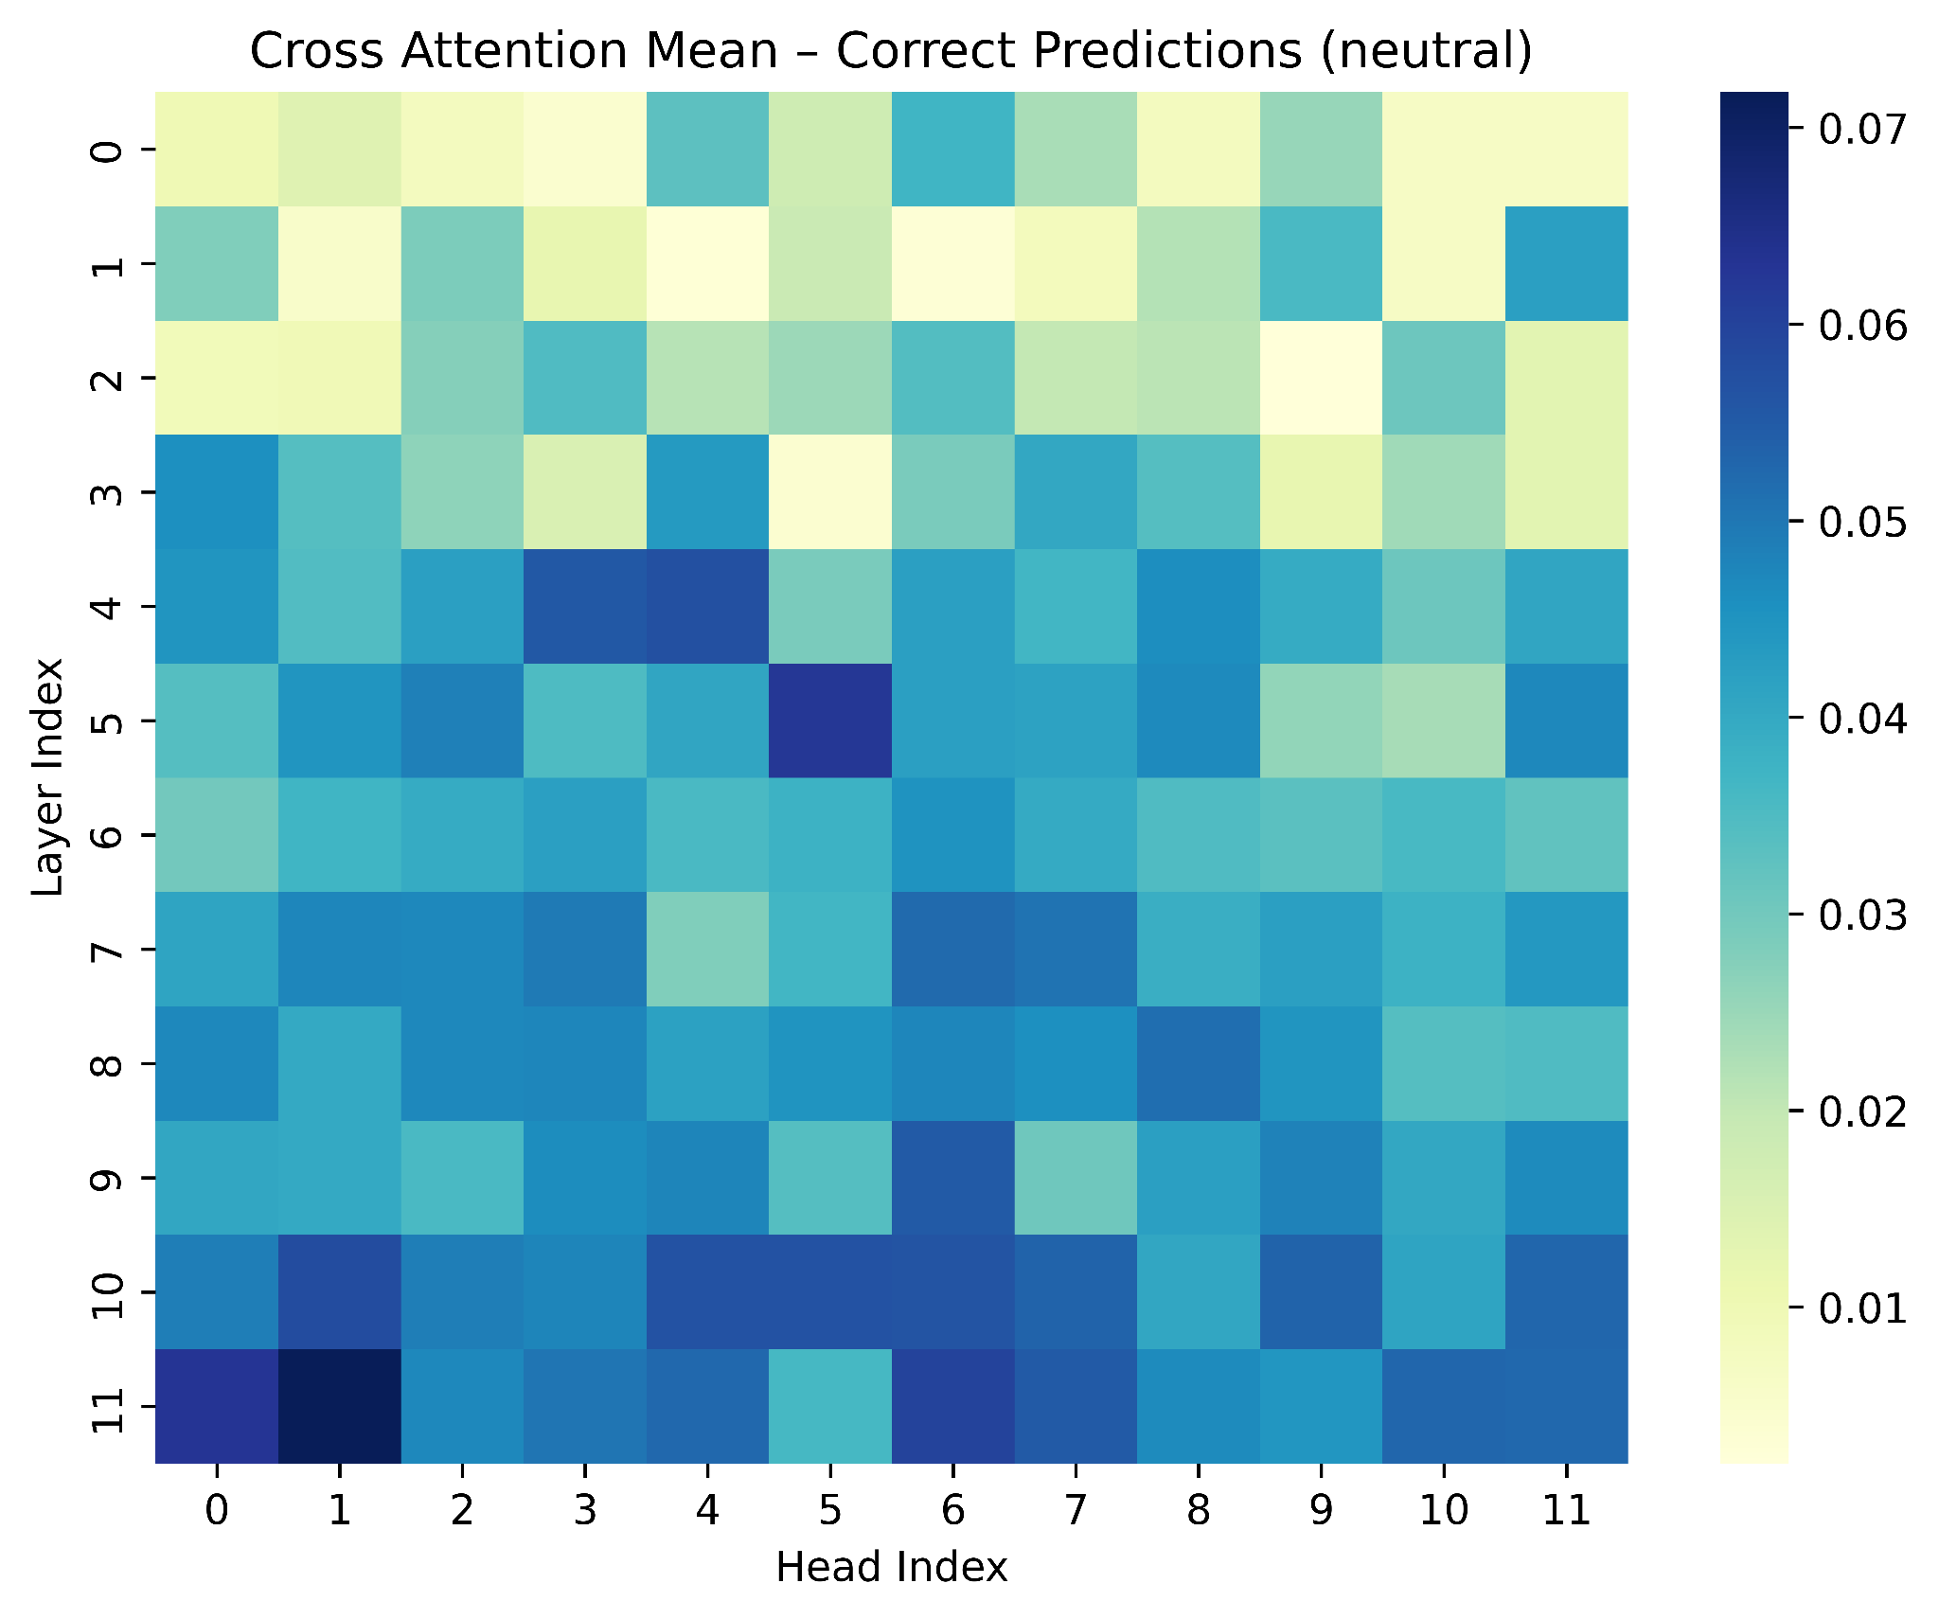

Figure 3. Mean cross attention scores for neutral prediction

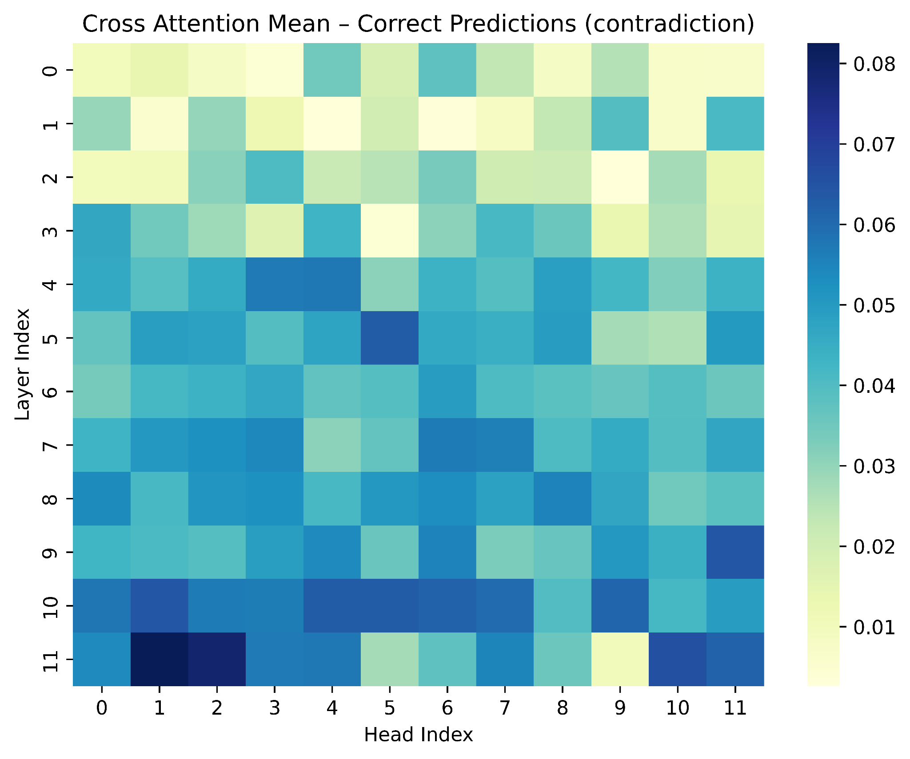

Figure 4. Mean cross attention scores for contradiction prediction

Figure 5 visualizes the variance across all layers with top 20 heads annotated in green and bottom 20 heads in yellow. It can be inferred that the shallow layers cannot learn detailed features with less variance for three tasks. Therefore, attention heads with lower scores will be removed to test if there are any benefits from the reducing parameters.
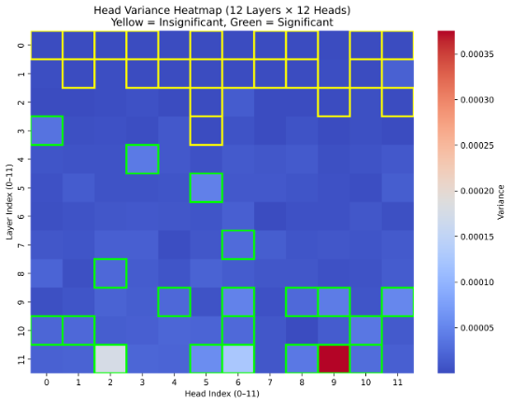
Figure 5. Head variance distribution for three classification tasks

Results
The impact of pruning was examined through two forms of analysis. The first analysis controlled removal based on a variance threshold, and the second controlled it by specifying a proportion of heads to eliminate. Figures 6 and 7 show that both approaches lead to similar outcomes.
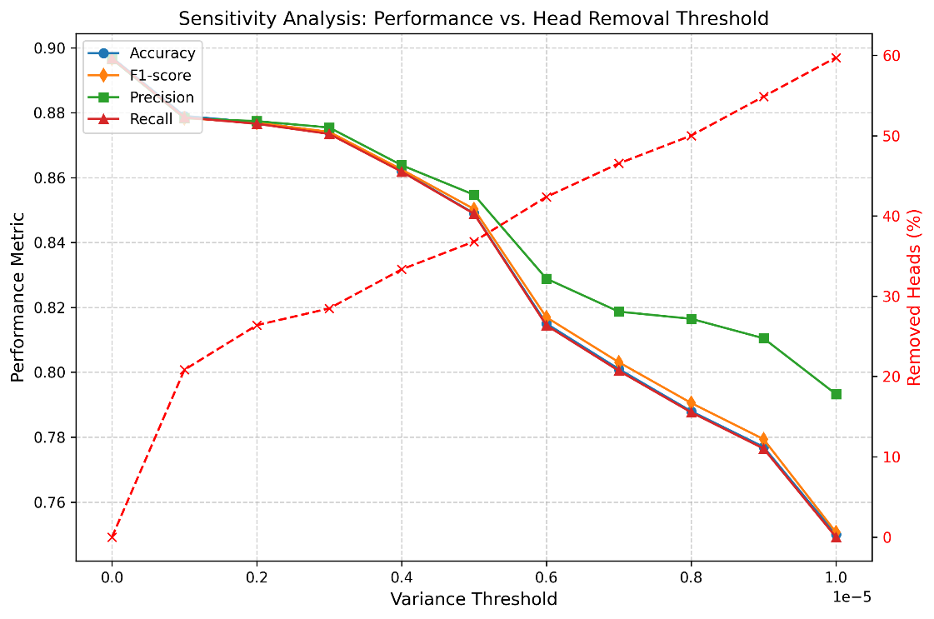
Figure 6. Sensitivity controlled by variance threshold
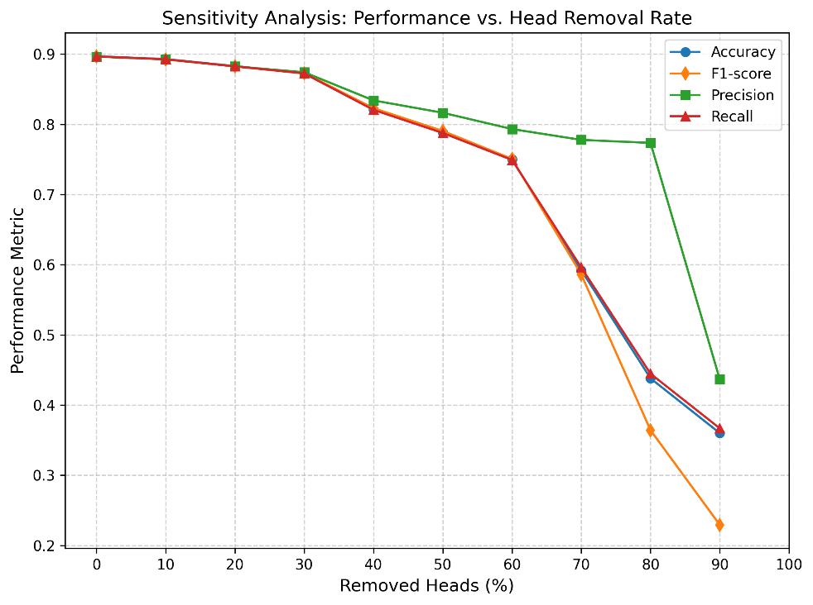
Figure 7. Sensitivity analysis controlled by removal rate
Removing heads with variance below 0.000001 corresponded to eliminating approximately 20 percent of all heads (32 heads). This level of pruning preserved model performance across all evaluation metrics. This shows that reducing low-variance heads doesn’t harm the model’s ability to perform natural language inference. Figure 8 shows the set of surviving heads after applying this reduction strategy, with most of the removed heads belonging to the early layers. It should be noted that the majority of the attention heads in the first 3 layers were removed.
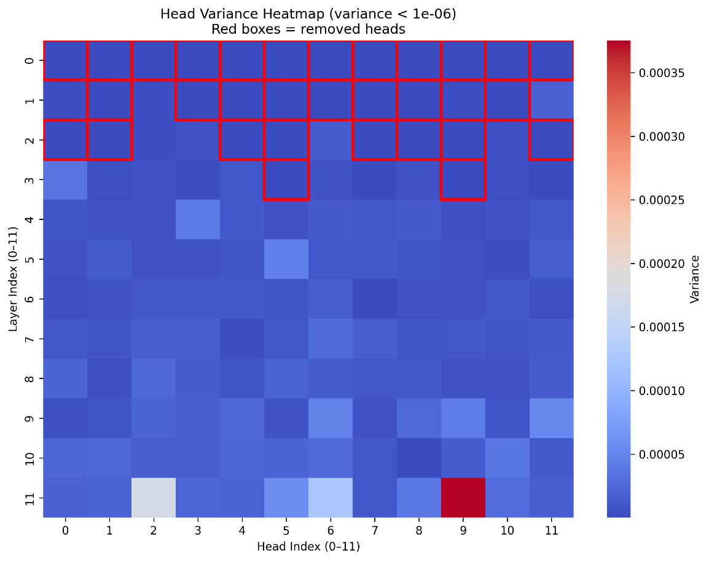
Figure 8. Available attention heads after reduction

To validate the effect of the pruning, we tested the pruned model on the remaining 8,824 samples of the SNLI test set. As illustrated in Figure 9, the evaluation shows a minor decrease in accuracy, precision, recall, and F1-score compared to the baseline model. This outcome shows that low-variance attention heads tend to contribute minimally to the classification decisions and can be safely removed with negligible impact on performance.

Although the current approach applies pruning after model inference, future work should integrate structured head-pruning during training to further examine its long-term stability and generalization behavior.

